April 17, 2023
The Honorable Jennifer M. Granholm
Secretary
U.S. Department of Energy
1000 Independence Ave., SW
Washington DC 20585

RE: 2023-02-01 Energy Conservation Program: Energy Conservation Standards for Consumer Conventional Cooking Products; Supplemental Notice of Proposed Rulemaking (EERE-2014-BT-STD-0005)
Dear Secretary Granholm,
We write to you today to submit public comment on the Department of Energy’s misguided effort to effectively ban the sale of nearly all existing gas stoves in America. While we understand the Department's objectives, we strongly believe that the supplemental notice of proposed rulemaking (SNOPR), referenced above, which seeks to propose new and amended energy conservation standards for consumer conventional cooking products is unwise, harmful to the Nation, and detrimental to our economy.
In response to comments made by Consumer Product Safety Commission Chair, Richard Trumka, where he stated “Any option is on the table. Products that can’t be made safe can be banned,” on January 11th White House press secretary Karine Jean-Pierre said clearly that “The president does not support banning gas stoves.” Yet just three weeks after that unequivocal statement was made, your Department proposed a rule that would effectively do just that.
For gas cooking tops, the SNOPR proposes a maximum efficiency level of 1,204 kBtu/yr. DOE tested 21 products for gas cooking and only one cooktop met the proposed level and no freestanding ranges met the level. According to your initial study, you proposed to regulate away all but 4% of the current market for stoves sold in America, no objective observer could call this anything other than a backdoor ban and a direct assault on consumer choice. After public backlash, the Department released further information suggesting that now only 50% of existing stoves meet the stringent regulation. However, none of the products manufacturers tested were able to meet the Department’s standards and manufacturers have said the vast majority of current products with features consumers demand would not meet the levels proposed. This rule poses serious consumer concerns and appears to be a direct attack on the use of natural gas with little to no consumer benefit.
We firmly believe in the free market and the ability of American citizens to make their own choices. By effectively banning gas stovetops through the imposition of excessively stringent efficiency standards, the Department of Energy is depriving Americans of the freedom to choose the type of appliance that best suits their needs, whether it be for cooking, heating, or any other purpose. This overreach not only infringes upon the rights of our citizens but also risks creating a potentially uncompetitive market by limiting the options available to consumers.
Millions of Americans, including those in our home states, rely on natural gas and propane for their daily needs. This SNOPR fails to account for the costs of fuel switching, or the costs to be borne by consumers for potential fuel switching. The sole consideration in the SNOPR with respect to costs relates to the costs to manufacturers for potential conversion. One company the Department analyzed would have to commit 83% of its annual revenue in testing and conversion costs to comply with the SNOPR. This glaring gap in the SNOPR fails to adequately respond to the anticompetitive effects of the rule, which will likely lead to manufacturers leaving the market and compelled fuel switching in order to purchase products in compliance with the max-tech standards proposed in the SNOPR.
Consumers deserve choice. Consumers deserve the ability to decide what appliances are in their homes. We strongly urge you to reject this approach and work towards more reasonable, market-driven solutions that promote energy efficiency and protect the interests of the American people. This means working with manufacturers and consumer groups to find energy efficiency standards that are reasonable, achievable, and beneficial to Americans. Instead of imposing standards that effectively eliminate gas stovetops, we encourage the Department of Energy to focus on promoting technological innovation, investing in research and development, and providing incentives for the voluntary adoption of more efficient appliances.

Sincerely,
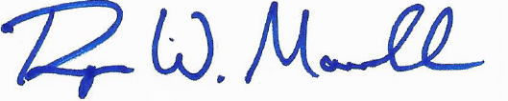
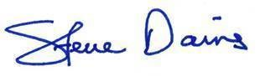

Roger Marshall, M.D. Steve Daines
United States Senator United States Senator
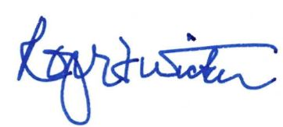
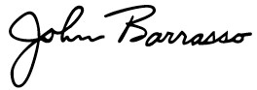

John Barrasso, M.D. Roger Wicker
Unites States Senator United States Senator
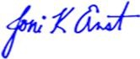

Todd Young Joni Ernst
United States Senator United States Senator
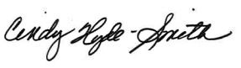

James Risch Cindy Hyde-Smith
United States Senator United States Senator
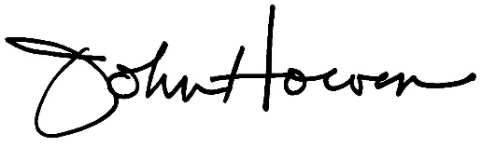
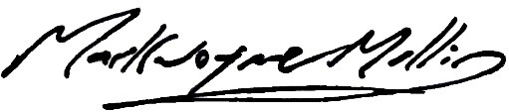

Markwayne Mullin John Hoeven
United States Senator United States Senator

